**DOG RECORD**

Member Name

Address

Contact Number

Member Prefix

DOGS NSW Membership Number

|  |  |  |  |
| --- | --- | --- | --- |
| Registered Name |  | | |
| Microchip No. |  | Sex |  |
| Registration No. |  | Breed |  |
| Date of Birth | / / | Colour |  |

**BIRTH HISTORY OF WHOLE LITTER**

Number of live females in the litter

Number of stillborn females in the litter

Number of females that died post-whelping

Number of live males in the litter

Number of stillborn males in the litter

Number of males that died post-whelping

Describe any birth complications

|  |  |
| --- | --- |
| Purpose of Dog | **** Exhibition **** Companion **** Breeding  (any discipline) |

*DOGS NSW Code of Practice-Record Keeping Information Booklet Dog Record*

*Issued December 2019 (Amended January 2021)*

**NEW OWNER DETAILS**

|  |  |  |  |  |  |
| --- | --- | --- | --- | --- | --- |
| Name |  |  | | |  |
| Residential address |  |  | | |  |
| Address where dog is housed |  |  | | |  |
| Contact Number |  |  | | |  |
| Microchip form transfer signed? | **E** Yes | **E** No | Microchip form transfer lodged? | **E** Yes | **E** No |
| Sales contract signed and given to new owner? | **E** Yes | **E** No | | |  |

***Note: Copy of microchip transfer form and signed contract/guarantee should be attached*DEATH/EUTHANASIA DETAILS**

/ /

Date of euthanasia (or death)

Vet clinic performing euthanasia

Reason for euthanasia (death)

**RETURN RECORD**

***Note: Copy of microchip transfer form must be attached***

*DOGS NSW Code of Practice-Record Keeping Information Booklet New Owner Details*

*Issued December 2019 (Amended January 2021)*

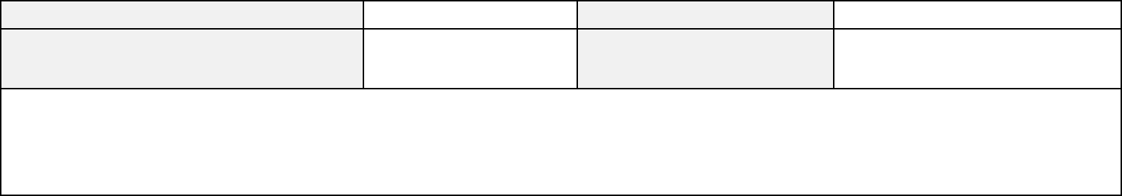

Microchip No.

Microchip form transfer signed?

Return reason

**E** Yes **E** No

Date: / /

Return date

Microchip form transfer lodged?

**E** Yes **E** No

Date: / /

/ /

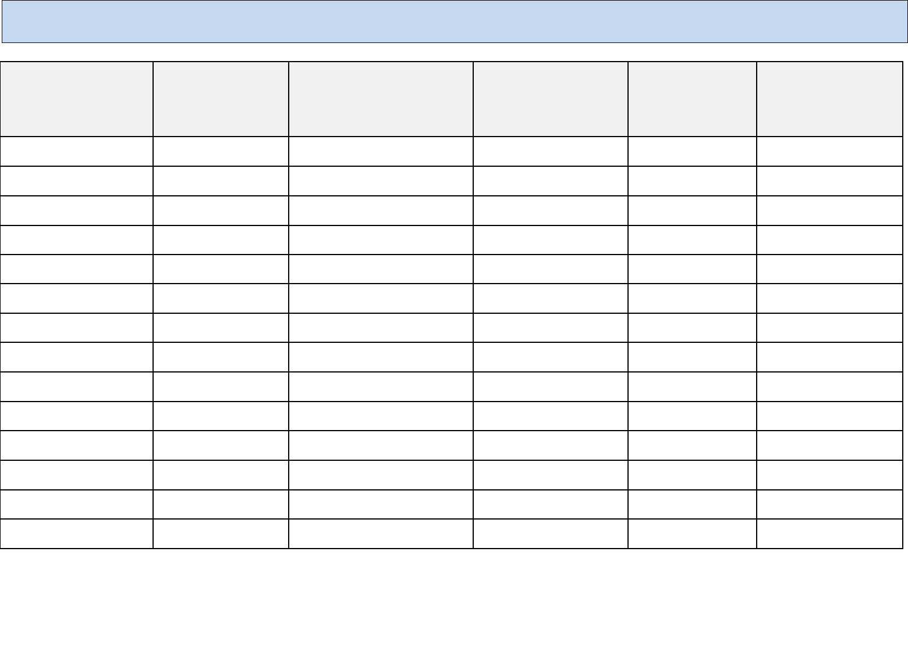

**Heartworm**

**Core Vaccine - C3   
(Distemper, Hepatitis,   
Parvovirus)**

**Fleas, Ticks &   
Mites**

**Date Given**

**Intestinal worms**

**Canine Cough   
(parainfluenza (Type II) &   
Bordetella bronchiseptica)**

**VACCINATION & WORMING HISTORY**

**(Must be accompanied by a copy of the veterinary issued vaccination record)**

/ /

/ /

/ /

/ /

/ /

/ /

/ /

/ /

/ /

/ /

/ /

/ /

/ /

/ /

*DOGS NSW Code of Practice-Record Keeping Information Booklet Vaccination & Worming Detail*

*Issued December 2019 (Amended January 2021)*

**GENERAL HISTORY**

**(Must be accompanied by a copy of any veterinary treatment record)**

|  |  |  |
| --- | --- | --- |
| **Date Given** | **Description of Illness/Injury** | **Treatment** |
| / / |  |  |
| / / |  |  |
| / / |  |  |
| / / |  |  |
| / / |  |  |
| / / |  |  |

*DOGS NSW Code of Practice-Record Keeping Information Booklet General History*

*Issued December 2019 (Amended January 2021)*

**REPRODUCTIVE HISTORY (BITCH)**

|  |  |  |  |
| --- | --- | --- | --- |
| Registered Name |  | | |
| Microchip No. |  | Date of Birth | / / |
| Attach copy of breeding clearance to this record (if required/obtained) |  | | |

|  |  |  |  |  |  |  |  |  |  |
| --- | --- | --- | --- | --- | --- | --- | --- | --- | --- |
| **Last annual health  certificate issue date** | **Mating/  Insemination  date  (List each  date)** | **Expected due  date** | **Sire  (Registered Name  Registered Number &  Microchip number)** | **Birth date** | **No. Live births**  **(Record colour/markings of each puppy)** | | **No. Stillborn** | | **Total  number  in Litter** |
| **Male** | **Female** | **Male** | **Femal**  **e** |
| / / |  | / / |  | / / |  |  |  |  |  |
| / / |  | / / |  | / / |  |  |  |  |  |
| / / |  | / / |  | / / |  |  |  |  |  |
| / / |  | / / |  | / / |  |  |  |  |  |
| / / |  | / / |  | / / |  |  |  |  |  |

**Attach copies of litter records whelped by this bitch here.**

*DOGS NSW Code of Practice-Record Keeping Information Booklet Reproductive History (Dog)*

*Issued December 2019 (Amended January 2021)*

**REPRODUCTIVE HISTORY (DOG)**

|  |  |  |  |
| --- | --- | --- | --- |
| Registered Name |  | | |
| Microchip No. |  | Date of Birth | / / |
| Attach copy of breeding clearance to this record |  | | |

|  |  |  |  |  |  |  |  |  |  |
| --- | --- | --- | --- | --- | --- | --- | --- | --- | --- |
| **Last annual health  certificate issue date** | **Mating/  Insemination  date  (List each  date)** | **Expected due  date** | **Female  (Registered Name  Registered Number &  Microchip number)** | **Birth date** | **No. Live births**  **(Record colour/markings of each puppy)** | | **No. Stillborn** | | **Total  number  in Litter** |
| **Male** | **Female** | **Male** | **Femal**  **e** |
| / / |  | / / |  | / / |  |  |  |  |  |
| / / |  | / / |  | / / |  |  |  |  |  |
| / / |  | / / |  | / / |  |  |  |  |  |
| / / |  | / / |  | / / |  |  |  |  |  |
| / / |  | / / |  | / / |  |  |  |  |  |

**Attach file notes**

*DOGS NSW Code of Practice-Record Keeping Information Booklet Reproductive History (Dog)*

*Issued December 2019 (Amended January 2021)*

**LITTER RECORD**

Member Name

Address

Contact Number

ANKC Breeding Prefix

DOGS NSW Membership Number

Breed

**Litter Parents Details   
Sire:**

|  |  |  |  |
| --- | --- | --- | --- |
| Registered Name |  | | |
| Microchip No. |  | Colour |  |
| Registration No. |  | Date of Birth | / / |

**Dam:**

|  |  |  |  |
| --- | --- | --- | --- |
| Registered Name |  | | |
| Microchip No. |  | Colour |  |
| Registration No. |  | Date of Birth | / / |

|  |  |  |  |  |
| --- | --- | --- | --- | --- |
| 1st Date of Season |  | | Date of Insemination | / / |
| Method of Insemination  (AI - Circle applicable type) | **** Natural | **** Artificial Insemination Fresh Chilled Frozen (Surgical/TCI)  (circle applicable insemination type) | | |
| Comments and observations on bitch  during gestation  (Food, medications, health, etc) |  | | | |

*DOGS NSW Code of Practice-Record Keeping Information Booklet Litter Record*

*Issued December 2019 (Amended January 2021)*

**WHELPING RECORD**

**Date first pup born: / /**

|  |  |  |  |  |  |  |  |  |
| --- | --- | --- | --- | --- | --- | --- | --- | --- |
| Puppy  No. | Time | Sex | Colour | Markings | Placenta | Presentation | Weight | Comments |
| 1 |  |  |  |  |  |  |  |  |
| 2 |  |  |  |  |  |  |  |  |
| 3 |  |  |  |  |  |  |  |  |
| 4 |  |  |  |  |  |  |  |  |
| 5 |  |  |  |  |  |  |  |  |
| 6 |  |  |  |  |  |  |  |  |
| 7 |  |  |  |  |  |  |  |  |
| 8 |  |  |  |  |  |  |  |  |
| 9 |  |  |  |  |  |  |  |  |
| 10 |  |  |  |  |  |  |  |  |

**Litter Details**

|  |  |  |  |
| --- | --- | --- | --- |
| Number of females in the litter |  | Number of males in the litter |  |
| Number of live births in the litter |  | Number of stillborns in the litter |  |

Describe any birth complications

*DOGS NSW Code of Practice-Record Keeping Information Booklet Whelping Record*

*Issued December 2019 (Amended January 2021)*

**LITTER WEIGHT RECORD**

|  |  |  |  |  |  |  |  |  |  |  |  |  |  |  |
| --- | --- | --- | --- | --- | --- | --- | --- | --- | --- | --- | --- | --- | --- | --- |
| Puppy ID | Birth | Day 1 | Day 2 | Day 3 | Day 4 | Day 5 | Day 6 | Day 7 | Day 8 | Day 9 | Day 10 | Day 11 | Day 12 | Day 13 |
| 1 |  |  |  |  |  |  |  |  |  |  |  |  |  |  |
| 2 |  |  |  |  |  |  |  |  |  |  |  |  |  |  |
| 3 |  |  |  |  |  |  |  |  |  |  |  |  |  |  |
| 4 |  |  |  |  |  |  |  |  |  |  |  |  |  |  |
| 5 |  |  |  |  |  |  |  |  |  |  |  |  |  |  |
| 6 |  |  |  |  |  |  |  |  |  |  |  |  |  |  |
| 7 |  |  |  |  |  |  |  |  |  |  |  |  |  |  |
| 8 |  |  |  |  |  |  |  |  |  |  |  |  |  |  |
| 9 |  |  |  |  |  |  |  |  |  |  |  |  |  |  |
| 10 |  |  |  |  |  |  |  |  |  |  |  |  |  |  |

Comments (progress of puppies plus dam; include full details of meals and fluids for dam)

*DOGS NSW Code of Practice-Record Keeping Information Booklet Litter Weight Record*

*Issued December 2019 (Amended January 2021)*

**LITTER WEIGHT RECORD/DATES WORMED/VACCINATED/MICROCHIPPED**

|  |  |  |  |  |  |  |  |
| --- | --- | --- | --- | --- | --- | --- | --- |
| Puppy ID | 2 weeks | 3 weeks | 4 weeks | 6 weeks | 8 weeks | 10 weeks | 12 weeks |
| 1 |  |  |  | Chip No. |  |  |  |
|  |
| 2 |  |  |  | Chip No. |  |  |  |
|  |
| 3 |  |  |  | Chip No. |  |  |  |
|  |
| 4 |  |  |  | Chip No. |  |  |  |
|  |
| 5 |  |  |  | Chip No. |  |  |  |
|  |
| 6 |  |  |  | Chip No. |  |  |  |
|  |
| 7 |  |  |  | Chip No. |  |  |  |
|  |
| 8 |  |  |  | Chip No. |  |  |  |
|  |
| 9 |  |  |  | Chip No. |  |  |  |
|  |
| 10 |  |  |  | Chip No. |  |  |  |
|  |

Comments (including weaning regime, food type and quantities, worming brand and dose and vaccination type and brand)

*DOGS NSW Code of Practice-Record Keeping Information Booklet Litter Weight Record/Dates Wormed/Vaccinated/Microchipped*

*Issued December 2019 (Amended January 2021)*

**GENERAL HEALTH HISTORY OF LITTER**

**(Must be accompanied by a copy of any veterinary treatment record)**

|  |  |  |
| --- | --- | --- |
| **Date** | **Description of Illness** | **Treatment** |
| **Example** |  | *Tube fed ‘Leerburg Formula’ 1ml per ounce body weight per feeding* |
| 1/1/2020 | *Puppies Numbers 2 and 4 – not nursing* | *every 3 hours. Supplementary feeding continuing.* |
| 12 noon |  |  |
| / / |  |  |
| / / |  |  |
| / / |  |  |
| / / |  |  |
| / / |  |  |

*DOGS NSW Code of Practice-Record Keeping Information Booklet General Health History of Litter   
Issued December 2019 (Amended January 2021)*

DOGS NSW LITTER RECORD V1 (10/19)

**PUPPY BEING REHOMED**

**(There must be a form completed for every puppy that leaves the breeder)**

|  |  |  |  |  |  |
| --- | --- | --- | --- | --- | --- |
| Registered Name |  | | | Breed |  |
| Registration No. |  | Gender |  | Colour |  |
| Microchip No. |  | | | Date of Birth | / / |

**New owner**

|  |  |  |  |  |  |
| --- | --- | --- | --- | --- | --- |
| Name |  |  | | |  |
| Residential address where dog will live |  |  | | |  |
| Contact Number |  |  | | |  |
| Microchip form transfer signed? | **E** Yes | **E** No | Microchip form transfer lodged? | **E** Yes | **E** No |
| Sales contract signed and given to new owner? | **E** Yes | **E** No | Health Certificate given to new owner? | **E** Yes | **E** No |

***Note: Copy of microchip transfer form and signed Sales Contract should be attached to this record*Return Record**

|  |  |  |  |  |  |  |  |  |
| --- | --- | --- | --- | --- | --- | --- | --- | --- |
| Registered Name |  |  |  | | | Breed |  |  |
| Registration No. |  |  |  | Gender |  | Colour |  |  |
| Microchip No. |  |  |  | | | Date of Birth | / | / |
| Microchip form transfer signed? | **E** Yes  Date: | **E** No / | / | Microchip form transfer lodged? | | | **E** Yes  Date: | **E** No  / / |
| Return Reason and Comments | |  |  | | | | |  |
|  | |  |  | | | | |  |

*DOGS NSW Code of Practice-Record Keeping Information Booklet Puppy Being Rehomed*

*Issued December 2019 (Amended January 2021)*

**PEDIGREE CHART**

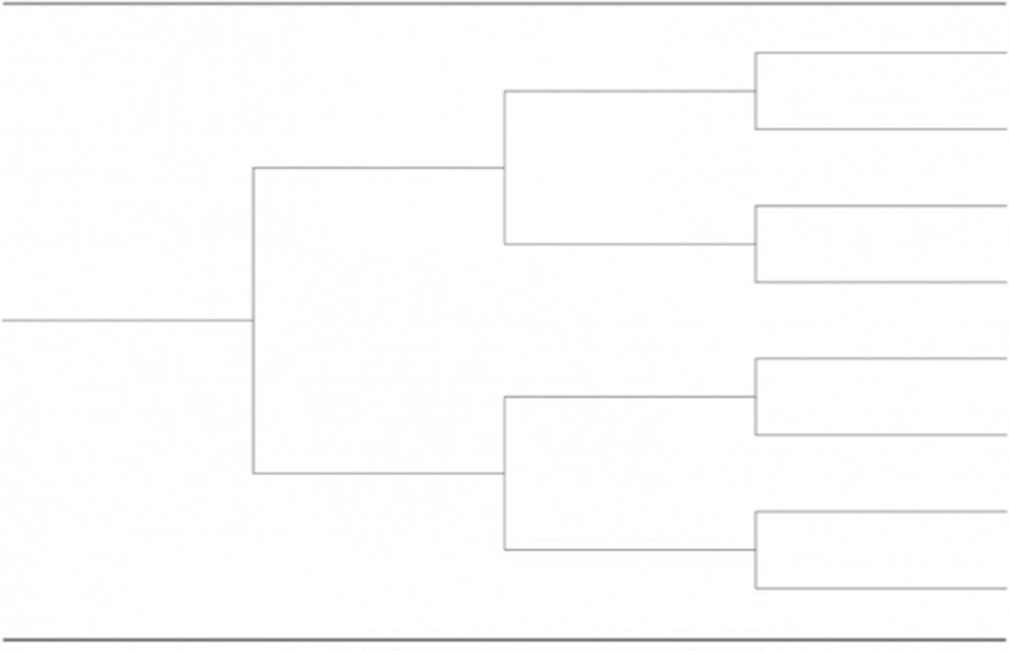

*DOGS NSW Code of Practice-Record Keeping Information Booklet Pedigree Chart*

*Issued December 2019 (Amended June2020)*

**PUPPY/ADULT DOG HEALTH CERTIFICATE**

To assist members with transparency in rehoming of healthy puppies/adult dogs.

If you or your Vet have an alternate form you prefer, please continue to use that.

**NOTE: It is important to record all matters that are not within normal health parameters, eg, heart murmur, hernia, undescended testicle(s), etc.**

*DOGS NSW Code of Practice-Record Keeping Information Booklet Puppy/Adult Dog Health Certificate*

*Issued December 2019 (Amended January 2021)*

**PUPPY/ADULT DOG HEALTH CHECK CERTIFICATE**

**Dog details**

|  |  |  |  |
| --- | --- | --- | --- |
| Registered Name |  | Date of Birth | / / |
| Microchip number |  | Gender |  |
| Breed |  | Colour |  |

**Physical Exam:**

WEIGHT: TEMP: PULSE/RESP:

**HYDRATION: E** Adequate **E** Marginal **E** Inadequate

Comments

**TESTICLES: E** 2 descended **E** 1 descended (L/R) **E** None descended **E** N/A

Comments

**HERNIA: E** No **E** Yes

Comments

*DOGS NSW Code of Practice-Record Keeping Information Booklet Puppy/Adult Dog Health Check Certificate*

*Issued December 2019 (Amended January 2021)*

**MOUTH:** ❑ Normal (Scissor Bite) ❑ Level Bite ❑ Overbite ❑ Underbite ❑ Other

Comments

**EYES:** ❑ Normal ❑ Conjunctivitis ❑ Glaucoma ❑ Cataracts ❑ Other

Comments

**SKIN:** ❑ Normal ❑ Hot Spots ❑ Fleas ❑ Mites ❑ Growth/Cyst ❑ Other

Comments

**EARS:** ❑ Normal ❑ Yeast ❑ Mites ❑ Other

Comments

**CARDIOVASCULAR:** ❑ Normal ❑ Murmur ❑ Arrhythmia ❑ Other

Comments

*DOGS NSW Code of Practice-Record Keeping Information Booklet Puppy/Adult Dog Health Check Certificate*

*Issued December 2019 (Amended January 2021)*

**RESPIRATORY: E** Normal **E** Infection **E** Other

Comments

**LYMPH NODES: E** Normal **E** Other

Comments

**MUSCULOSKELETAL: E** Normal **E** Other

Comments

**GENITOURINARY: E** Normal **E** Other

Comments

**GASTROINTESTINAL: E** Normal **E** Other

Comments

*DOGS NSW Code of Practice-Record Keeping Information Booklet Puppy/Adult Dog Health Check Certificate*

*Issued December 2019 (Amended January 2021)*

**OVERALL HEALTH CONDITION: E** Excellent **E** Good **E** Fair **E** Poor

Comments

**Veterinarian’s Name** *(please print)*

**Veterinarian’s Signature** *(please sign)*

**Date:**

**Clinic Name:**

**Phone:**

**Clinic Address:**

**Web*:***

*DOGS NSW Code of Practice-Record Keeping Information Booklet Puppy/Adult Dog Health Check Certificate*

*Issued December 2019 (Amended January 2021)*

**BREEDING CLEARANCE**

To assist members with compliance with:-

* DOGS NSW Regulations Part XIII-Code of Ethics, Clauses 8, 9 and 12
* Animal Welfare Code of Practice for Breeding Dogs and Cats, Section 10

If you or your Vet have an alternate certificate, you can continue to use it in place of this sample template.

*DOGS NSW Code of Practice-Record Keeping Information Booklet Breeding Clearance*

*Issued December 2019 (Amended January 2021)*

**BREEDING CLEARANCE CERTIFICATE**

**Bitch details**

|  |  |  |  |
| --- | --- | --- | --- |
| Registered Name |  | Date of Birth |  |
| Microchip number |  | Gender | *Female* |
| Breed |  | Colour |  |

Veterinary Practitioner’s name

Practice: Name & Address

Contact Number

DOGS NSW Member’s Name

ANKC Ltd Registered Prefix

DOGS NSW Membership Number

**Declaration**

I , today examined the bitch identified above

being years of age and, in my opinion, there are no impediments to this animal being used for breeding.

Signed:

Date:

|  |
| --- |
| Comments |

*DOGS NSW Code of Practice-Record Keeping Information Booklet Breeding Clearance Certificate*

*Issued December 2019 (Amended January 2021)*

**IN CASE OF EMERGENCY**

Contact Details for the Care of my Dog(s) at Home

|  |
| --- |
| Full Name (owner):  Address:  Contact number:  My Dog’s Name:  Microchip Number:  (Breed, likes, dislikes, age, distinguishing markings) medical conditions, neutered etc)  In an emergency please contact the following:-  1.  2.  3.  Please ensure that at no point should the above-named dog be surrendered to any party other than those named.  Signed  [Place photo of dog here] |

*DOGS NSW Code of Practice-Record Keeping Information Booklet Breeding Clearance Certificate*

*Issued December 2019 (Amended January 2021)*