Date:
Dear,
The following dog has been observed interfering with the field equipment. At the expiry of the grace period noted below, your dog is required to wear a muzzle at [ Affiliate Name: ] events per Section 5.9 of the Rules for the Conduct of Lure Coursing Competitions.

Dog Registered Name:

Registration Number:

Owner:

Date Requested:

3 Month Grace Period Expires:

Name & Signature of Affiliate representative_________________________________________

Name & Signature of owner/ handler_______________________________________________

5.9 An affiliate club can request that the owner of a dog that is running in other Classes, and which has a history of interfering with the field equipment, wear a muzzle to prevent damage to the field equipment and to the dog itself. Should an affiliate request a handler to muzzle their dog under this provision, the handler has a grace period of 3 months to muzzle train the dog. Suitable Muzzle Styles
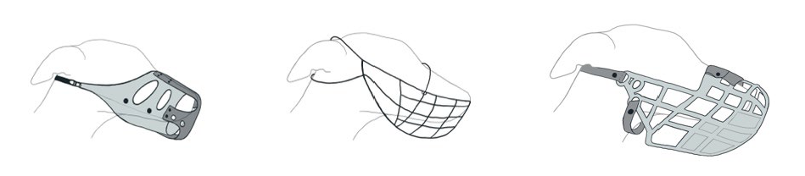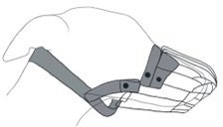
Please Note: Wire muzzles are not permitted.

